Technical Architecture Document
EPS
e-Parliament Services

Approval
Name | Role  MOA/MOE | Date  Approval | Approval  Y/N | Address  DG or Company
Gianluigi Alari | e-Parliament program manager  MOA |  |  | ITEC
Olivier Fabbri | Project Manager |  |  | ITEC

CIRCULATION
Name -Telephone number |  | DG or Company | ERICA code
Gianluigi Alari (GAL) |  | ITEC | C
Jesus Cerro (JCE) |  | ITEC | C
Bogdan Boranda (BBO) |  | ITEC | C
Jacques Militello (JMI) |  | ITEC | C
Olivier Fabbri (OFA) |  | ITEC | R

Updates
Version | Date | Sections changed | Description | Author(s)
1.0 | 08/01/2013 | all | document creation | OFA
1.1 | 21/01/2013 | 2.3,2.4,2.61,2.6.3.1 | updates following ICTAS first remarks | OFA
1.2 | 24/01/2013 | 2.2  2.3  2.4  2.6.1 | updates following ICTAS remarks:  - insertion of the name of the modules  - explanation of the multi war files deployment  - request different runtimes for the different modules  - update of the schema with the name of the war files and change of protocol for REST web services. | OFA
1.3 | 13/02/2013 | 2.2  2.4  2.6 | - HornetQ nomenclature ending the instance in "Q"  - Justification for 2 tomcat instances (performance reasons)  - Dependency between EPS and PURE-XML explained)  - Oracle connections | BBO
Table of content
1. General Introduction 4
1.1. Purpose 4
1.2. Usage conventions 4
1.3. Applicable and Reference Documents 4
1.4. Glossary 4
1.5. Procedure 'Technical Architecture' 5
2. Architecture - Description 6
2.1. Basic information 6
2.2. Network Architecture Schema 6
2.3. Software Architecture 7
2.4. Required Standard Runtimes 8
2.5. Non-standard server-side softwares list 8
2.6. Integration 9
2.7. Security 11
3. Specific Development Tools 12

General Introduction

Purpose
This document contains a description of the EPS project for submission to the IT correspondent of the DIT for its opinion on the technological/technical assumptions on which it is based. It is essential for this opinion to be sought in order to ensure that the elements on which the project's success will depend (methods, architectures, tools, components, etc.) are valid and authorised within the EP.

Usage conventions
The parts in yellow indicate the area where information should be entered, and must remain in yellow to highlight information connected with the project.
Where a chapter or section is not considered to be applicable, put ‘NOT APPLICABLE’.
Click on the Show/Hide button in the toolbar to display/hide guidance on filling in this document.
Guidance displayed.

Applicable and Reference Documents
This chapter sets out the reference documents on which this guide is based.

Applicable Documents
This section details the applicable documents used in drafting this document. The applicable documents are standards, specimen plans which need to be applied and whose application is verifiable.
N° | Title | Remarks
[1] | EPS_CHP_EN_v10.doc | Project Charter
[2] | EPS_DEB_EN_v10.doc | Needs study
[3]

Reference Documents
This section details the reference documents used in drafting this document. Reference documents help in defining the project but are not directly applicable (e.g. software reference manuals, sample files from outside firms, meeting papers).
N° | Title | Remarks
[1]
[2]
[3]

Glossary
The glossary is available at ICTASnet : - Zone 'Vos indispensables'-Glossaire.
Abbreviation | Description
DTA | Technical Architecture Document
RHR | Runtime Hosting Request

Procedure 'Technical Architecture'

Sending a Technical Architecture Document (DTA)
The DTA and/or RHR(s) documents have to be sent to the IT correspondent of the DIT.

Validation of the DTA
As soon as the DTA is completely validated then the DTA is sent to ITO to continue the treatment along with one or multiple Runtime Hosting Requests (RHR).

ICTAS support
During the project, ICTAS can support the team project (MOA+MOE) but on request only.
ICTAS provides relevant information (standard, methods) in the Quality Assurance Manual and the appropriate documents (templates) for the project.

ITO support
ITO deals with the DTA as soon as it is validated by ICTAS.
ITO initiates a meeting with the stakeholders of the project in order to organise the technological environments necessary for the project.
For more information see ITO Website.

Architecture - Description

Basic information
This chapter describes the deliverables (applications, components, integration component) of the product in the EP's network using a synthetic schema.
Service | Required
Intranet | Y
DMZ | N
VLAN dedicated | N
Internet access through the EP portal | N
Other | N

Network Architecture Schema
e-Parliament Services will be a set of services or libraries that will be commonly used by different projects/products in the context of the e-Parliament Program.

- "PURE-XML Service Layer" (PSL): this module will provide products with a service layer to address the PURE-XML repository
- "TOPOLINO" (TPL): this module is a listener to EPADES 2 circuits that will trigger actions to consume a step and provide information to the applications plugged to the next step
- "XML4EP lib" is a library to work with XML4EP format

All the services offered by EPS are stateless.
These services will be accessed it via its API (Java binding or Web Services binding) or using JMS.

The network topology complies with the regular J2EE Intranet network architecture:
  - EPS application is hosted on an in-house J2EE server (Tomcat) and accessed in the Intranet via HTTP protocol
  - Authentication will not be implemented.
  - No authorisation will be implemented.
  - The persistence layer is assured by in-house Oracle databases

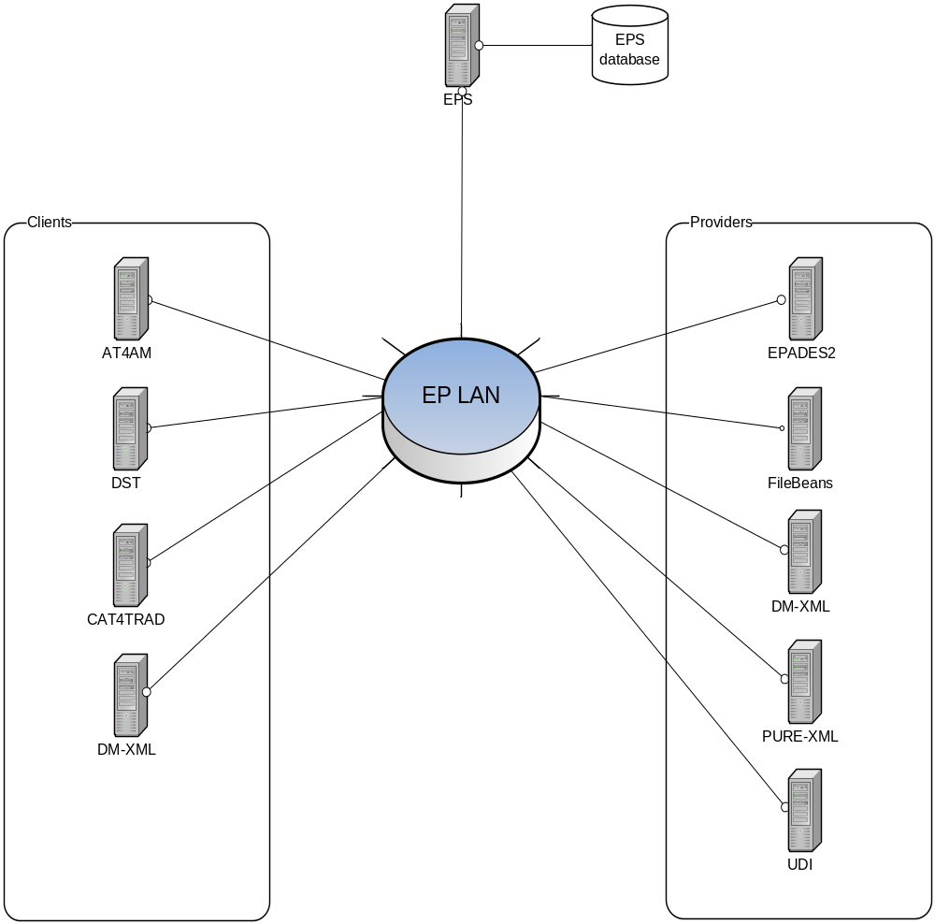Insert a synthetic schema representing general software components in their respective network zones (application servers, applications, products...etc), as well as their interactions and the protocols used for these interactions.

Software Architecture

This chapter describes the software architecture according to the following schema:
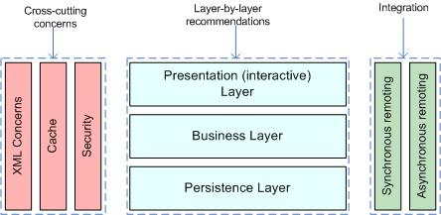
List the technologies/libraries used.

Client User interface | N
Server Presentation layer | N
Server Business layer | Spring 3.1.3 (latest production release)
Server Persistence Layer | Spring Data 1.1/JPA / HIBERNATE 4.1.7
RDB | Oracle (latest official release)
Synchronous Remoting (WS, RMI...) | Spring MVC 3.1.x for RESTful Web Services
Asynchronous Remoting (JMS...) | JMS with HornetQ 2.2.X client
XML Handling | JAXP / StAX / TrAX
Cache | Ehcache 2.6.2
Security | Authentication not implemented in the current scope. Authorisation not implemented in the current scope.
XSLT Processor | Saxon-HE 9.3
XSLT 2.0 | Saxon-HE 9.3
Other | Jackson 1.9.11 (latest official release)

Document generation: Aspose.Word for JAVA

The deployments will be done using two war files.
Each war will have differect lifecycle.
First wars is for EPSPSL (EPS for Pure-XML Service Layer, including the XML4EP lib). This will be deployed on the EPSPSL Tomcat instance.

Second war is for EPSTPL.
This will be deployed on the EPSTPL Tomcat instance.

Required Standard Runtimes
This chapter lists the various required server-side softwares (for example, Tomcat, HornetQ...etc), and their runtime codes (allowing to map this document with multiple Runtime Hosting Request(RHR).
List of required operational environment and associated 8 characters Code:
Existing  (Y/N) | Standard Runtime | Code  (8 char) | Environment(s)  DEV, PPO, FOR, PROD, INT
N | Tomcat 6.0.x | EPSPSL | DEV, INT, PPO, PROD
N | HornetQ 2.2.x | EPSPSLQ | DEV, INT, PPO, PROD
N | Tomcat 6.0.x | EPSTPL | DEV, INT, PPO, PROD

EPS system needs two Tomcat instances for performance reasons: EPSPSL is an intensive module that needs its own instance.

First Tomcat Server (EPSPSL) will connect to the Oracle Database.
Second Tomcat Server (EPSTPL) doesn't require connection to database.

Please note that one separate RHR document will be needed for each new runtime.

Non-standard server-side softwares list
This chapter lists the various required non-standard server-side softwares.
Please note that these non-standard pieces of software are most likely not to be accepted quickly, though may trigger special attention and dedicated handling.
Fill in this chapter as accurately as possible.

Non-Standard Server-side software | Explanation of the need
Saxon-HE 9.3 | Saxon supports XSLT 2.0, unlike Xalan that only supports XSLT 1.0.
Jackson 1.9.11 | Jackson is the richest and most widely used JSON library in Java.

Integration
This chapter describes integration of the product with other applications or services (Database, directory, etc.) and contracts and protocols used.

Applications integration schema
This section has to contain a schema describing interactions between applications. You have to precise the protocols used, and information needed to describe the exchanges (synchronous (remoting, web services), asynchronous (JMS, etc.).
Several e-Parliament projects will call EPS stateless services:
- AT4AM
- DST
- CAT4TRAD
- DM-XML

EPS will call some applications using stateless services:
- PURE-XML
- DM-XML
- FILEBEANS
- UDI

EPS will call some applications using statefull services:
- EPADES2

EPS will listen to some applications JMS topics/queues:
- EPADES2

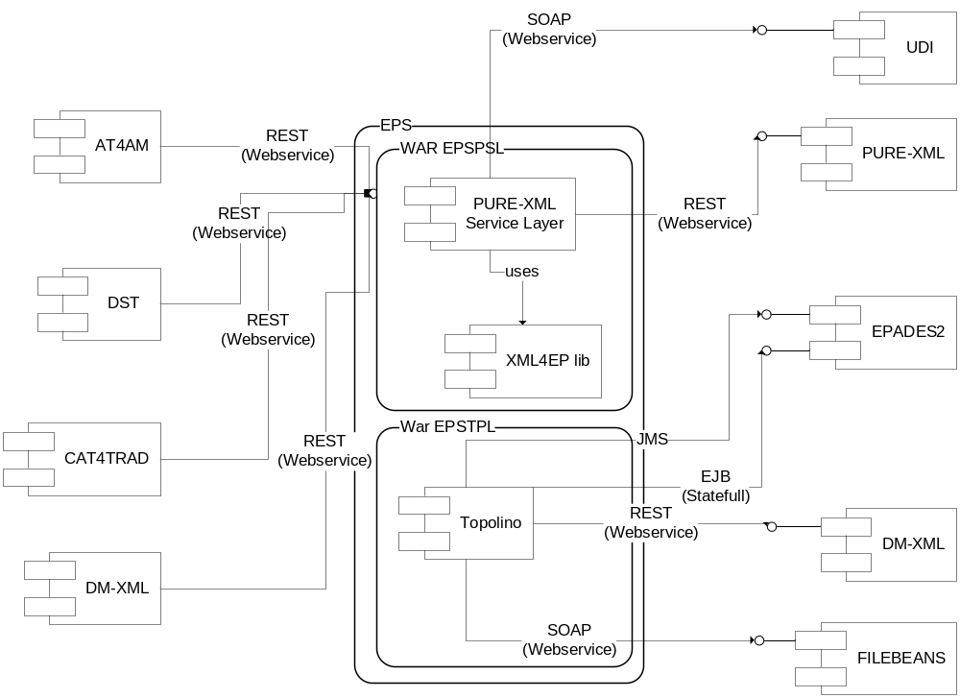

Application integration criticality
Reference | Protocol | Synchronicity | Frequency | Business Criticality
AT4AM | HTTP | Synchronous | <100/min | High
DST | HTTP | Synchronous | <100/min | High
CAT4TRAD | HTTP | Synchronous | <100/min | High
DM-XML | HTTP | Synchronous | <100/min | High
PURE-XML | HTTP | Synchronous | >1000/min | High
EPADES2 | EJB | Synchronous | <100/min | High
EPADES2 | JMS | Asynchronous | <100/min | High
UDI | SOAP | Synchronous | <100/min | High
FileBeans | SOAP | Synchronous | <100/min | High

AT4AM, DST and CAT4TRAD need EPS - PURE-XML Service Layer to store XML in PURE-XML.

EPS has no direct dependency to PURE-XML. If PURE-XML is down, EPS will handle gracefully the unavailability at the business layer and it will reconnect to PURE-XML once the external system is up and running (after a shut down, restart, update or error).

There is no dependency from PURE-XML towards EPS. If EPS is down PURE-XML will function without any impediment.

DM-XML is needed to generate PDF or Word versions of XML-Document, which is need in the context of e-Parliament, and triggered by EPS, consuming EPADES2 steps.

System

List of required system services
Database | Oracle 10.2.0.5
File system (direct access, sharing, FTP, ...) | Direct access
Directory (Active Directory, other) | N
Mails (Sending mails from an application) | N
Application Server | EP Tomcat 6.0.18
JDBC | Oracle OCI driver 10.2.0.3.0
Other | N

System services schema (optional)
For clarity (and mostly if you have asked for multiple runtimes), please provide a schematic vision of the interaction between system services and applications.

Security
This chapter describes the needs for security (secure client access, integration, confidentiality (signature) data exchanged or stored, business services implemented, etc.).

Authentication mechanism

No authentication foreseen at this stage.

Authorization mechanism
No authorisation foreseen at this stage.

Specific confidentiality needs
None

Specific Development Tools
The purpose is to mention only components which need a special or specific attention
The ICTAS Unit provides standard tools for the development of applications.
Mention here licence-limited tools you may need (restricted use product):

Oxygen XML | Y
Modelling tool UML | Y
Maven | Y
Source management (SVN) | Y
Full Application server | N

Non standard tools and justification:

E: Examination, R: Responsible, I: Information, C: Contribution, A: Approval
Runtime: for example: Tomcat, HornetQ...etc
Environment (DEV, PPO, FOR, PROD, INT...etc)
An identifier helping to point this relation in the Application Integration Schema
Frequency of the interaction (e.g. once every night for a batch, thousands of calls per minute if directly related to end user input or interaction)

